
JC2 PRELIMINARY EXAMINATION
TAMPINES MERIDIAN JUNIOR COLLEGE

CANDIDATE
NAME
CIVICS GROUP
_________________________________________________________________________________
H2 GEOGRAPHY 9173/02
Paper 2 16 September 2024 3 Hours

INSERT
___________________________________________________________________________

READ THESE INSTRUCTIONS FIRST

This Insert contains all the Resources referred to in the questions.

_________________________________________________________________________________

This document consists of 8 printed pages
Resource 1 for Question 1
Photos taken by students during their fieldwork

Sugamo district, Tokyo
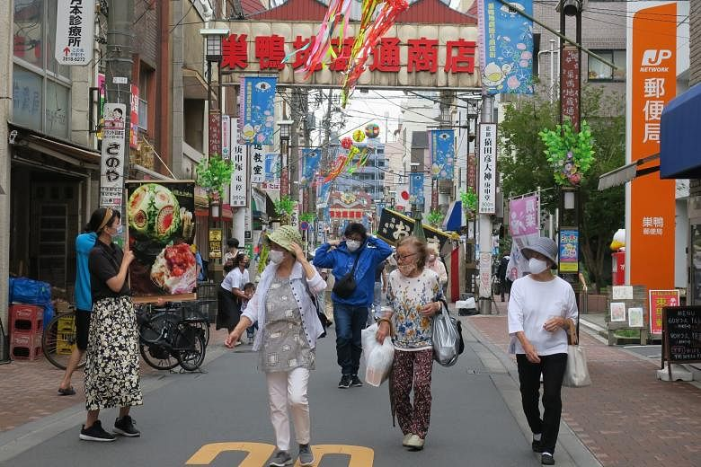

San’ya district, Tokyo
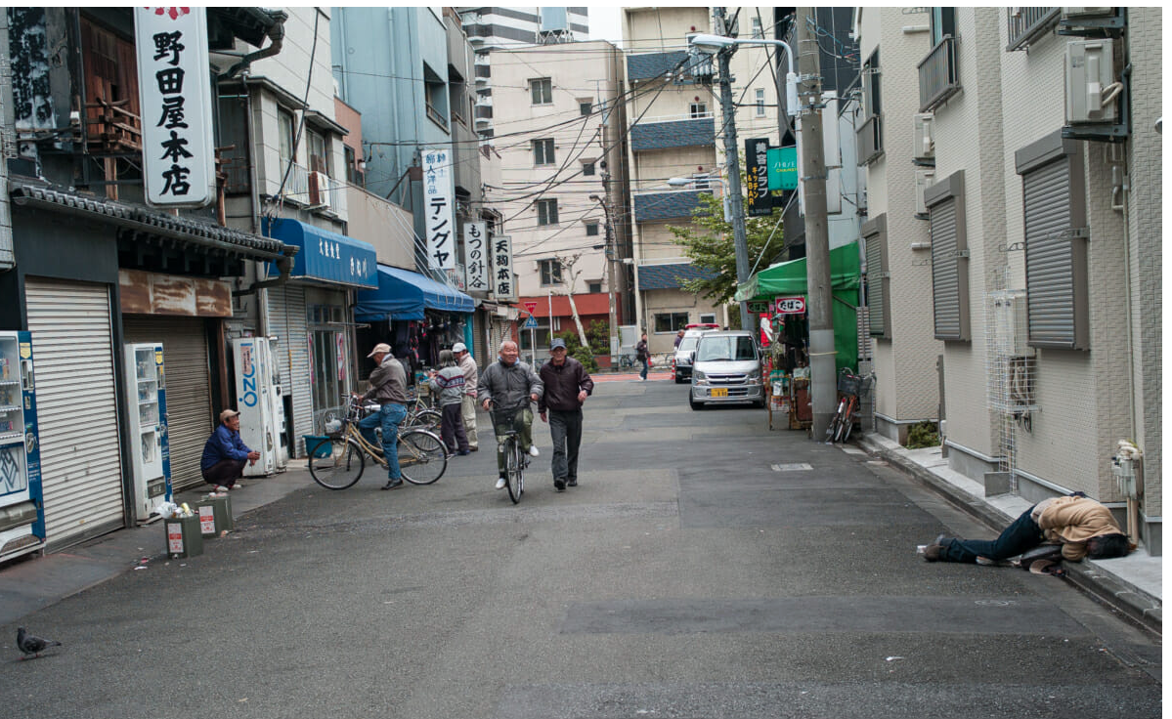
Resource 2 for Question 1

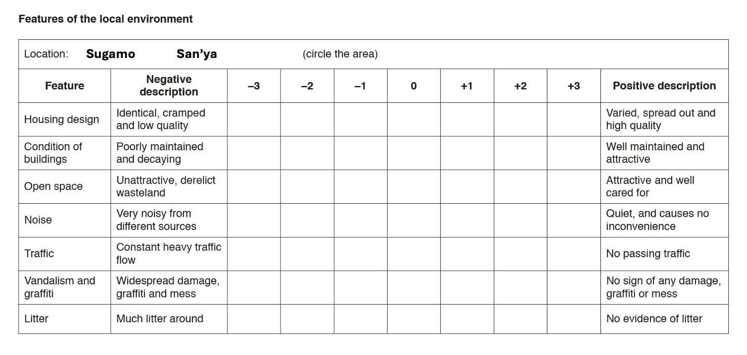
Environmental quality survey form

Resource 3 for Question 1
Students’ and residents’ perception of environmental quality in Sugamo and San’ya

Students’ results

Feature | San’ya | Sugamo
Housing design | -3 | 0
Condition of buildings | -2 | +1
Open space | -2 | +1
Noise | 0 | +1
Traffic | -1 | +2
Vandalism and graffiti | -2 | +3
Litter | 0 | +1
Total score | -10 | +9

Residents’ results

Feature | San’ya | Sugamo
Housing design | -1 | +1
Condition of buildings | +1 | +2
Open space | -2 | 0
Noise | -1 | 0
Traffic | +1 | 0
Vandalism and graffiti | 0 | +1
Litter | +1 | +1
Total score | -1 | +5

Resource 4 for Question 1
Residents’ perception of quality of life in Sugamo and San’ya

Sugamo

 | Number of responses from residents
Aspect of the local area | Excellent | Good | Satisfactory | Poor | Very poor
Cost of necessities | 5 | 7 | 6 | 4 | 3
Health services | 4 | 9 | 6 | 3 | 3
Parks and playgrounds | 6 | 6 | 7 | 3 | 3
Personal safety | 4 | 5 | 6 | 4 | 6
Community spirit | 7 | 5 | 9 | 3 | 1
Total | 26 | 32 | 34 | 17 | 16

San’ya

 | Number of responses from residents
Aspect of the local area | Excellent | Good | Satisfactory | Poor | Very poor
Cost of necessities | 2 | 4 | 10 | 5 | 4
Health services | 3 | 6 | 8 | 6 | 2
Parks and playgrounds | 1 | 2 | 9 | 7 | 6
Personal safety | 3 | 6 | 5 | 6 | 5
Community spirit | 2 | 4 | 7 | 3 | 9
Total | 11 | 22 | 39 | 27 | 26

Resource 5 for Question 2
Population growth of the world’s 8 largest cities

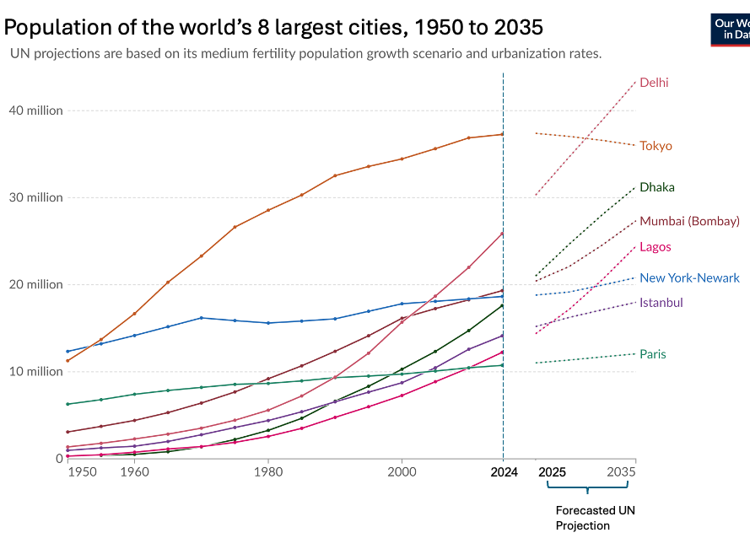

Resource 6 for Question 2

Changes in Marina Bay Area, Singapore

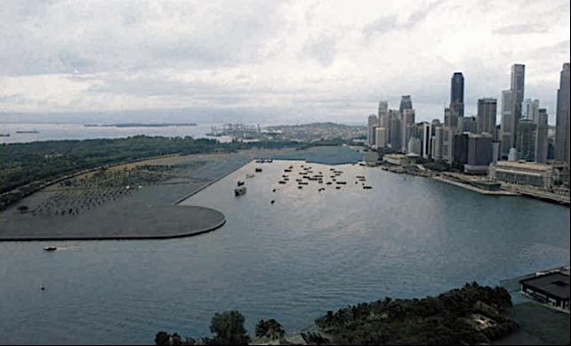
2002

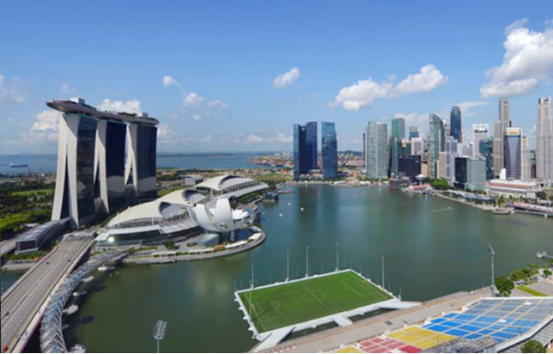
2022

Resource 7 for Question 2
Liveability city ranking for selected cities

